System Design Documentation

# ER Diagram & UML Summary – Video Conferencing App

Date: 26 May 2025

Project Name: Video Conferencing App

Maximum Marks: 4 Marks

## 1. Entity–Relationship Diagram

This ER Diagram illustrates a potential future database schema for the Video Conferencing App. It includes entities such as Room, Participant, ChatMessage, and Recording to support analytics, moderation, and logging.

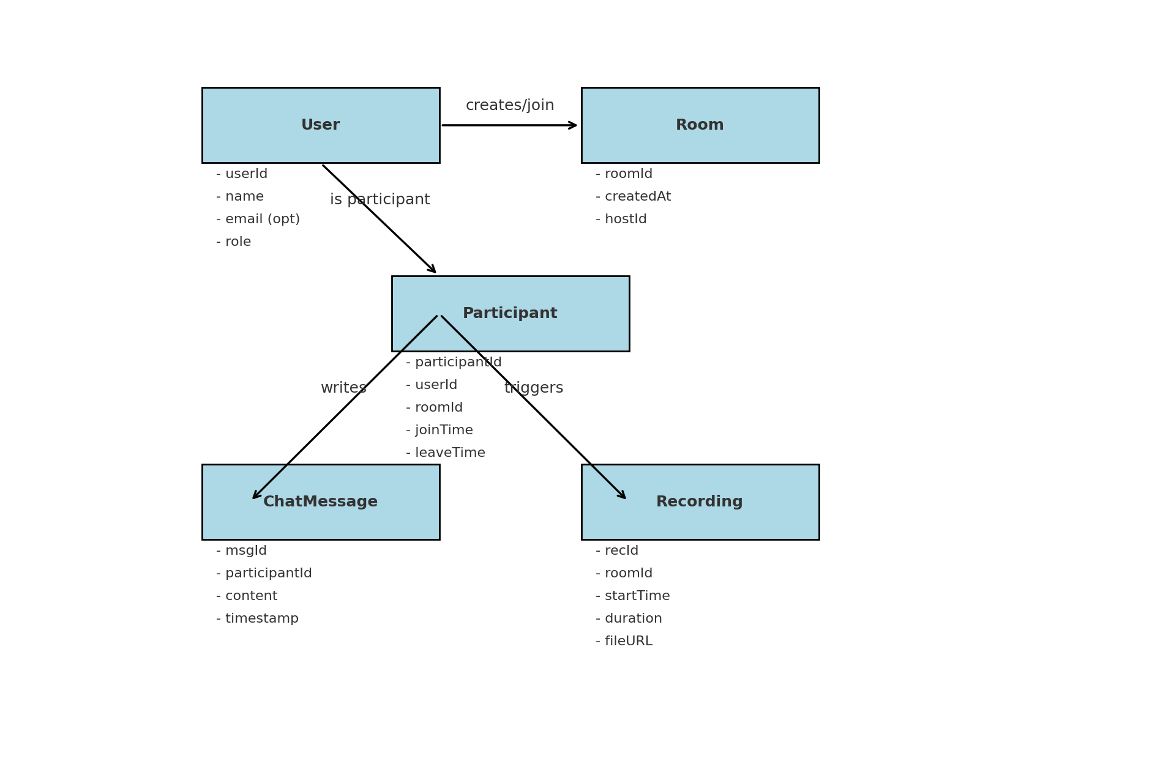

## 2. UML Summary Diagrams

### 2.1 Use Case Diagram

This diagram shows the various use cases for end users such as joining a room, toggling mic/camera, and recording sessions.

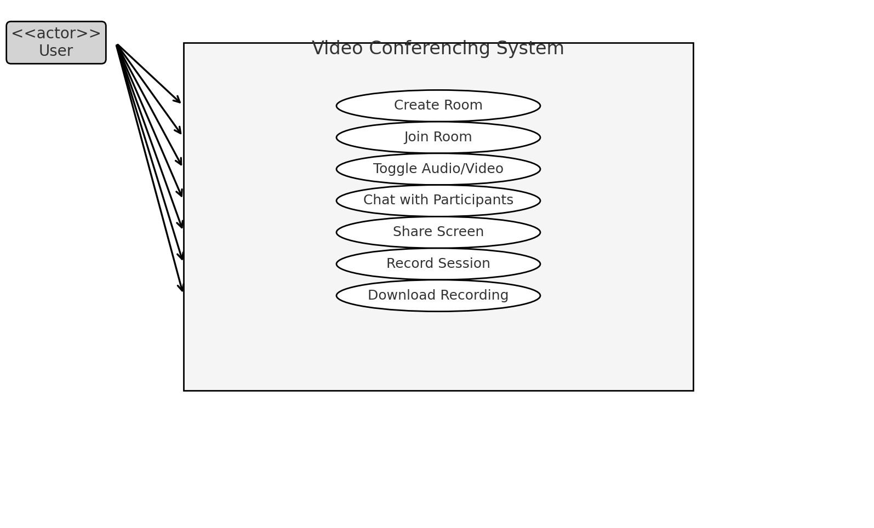

### 2.2 Class Diagram

This simplified class/component diagram illustrates the core modules in the system such as the peer handler, screen sharing, and chat service.

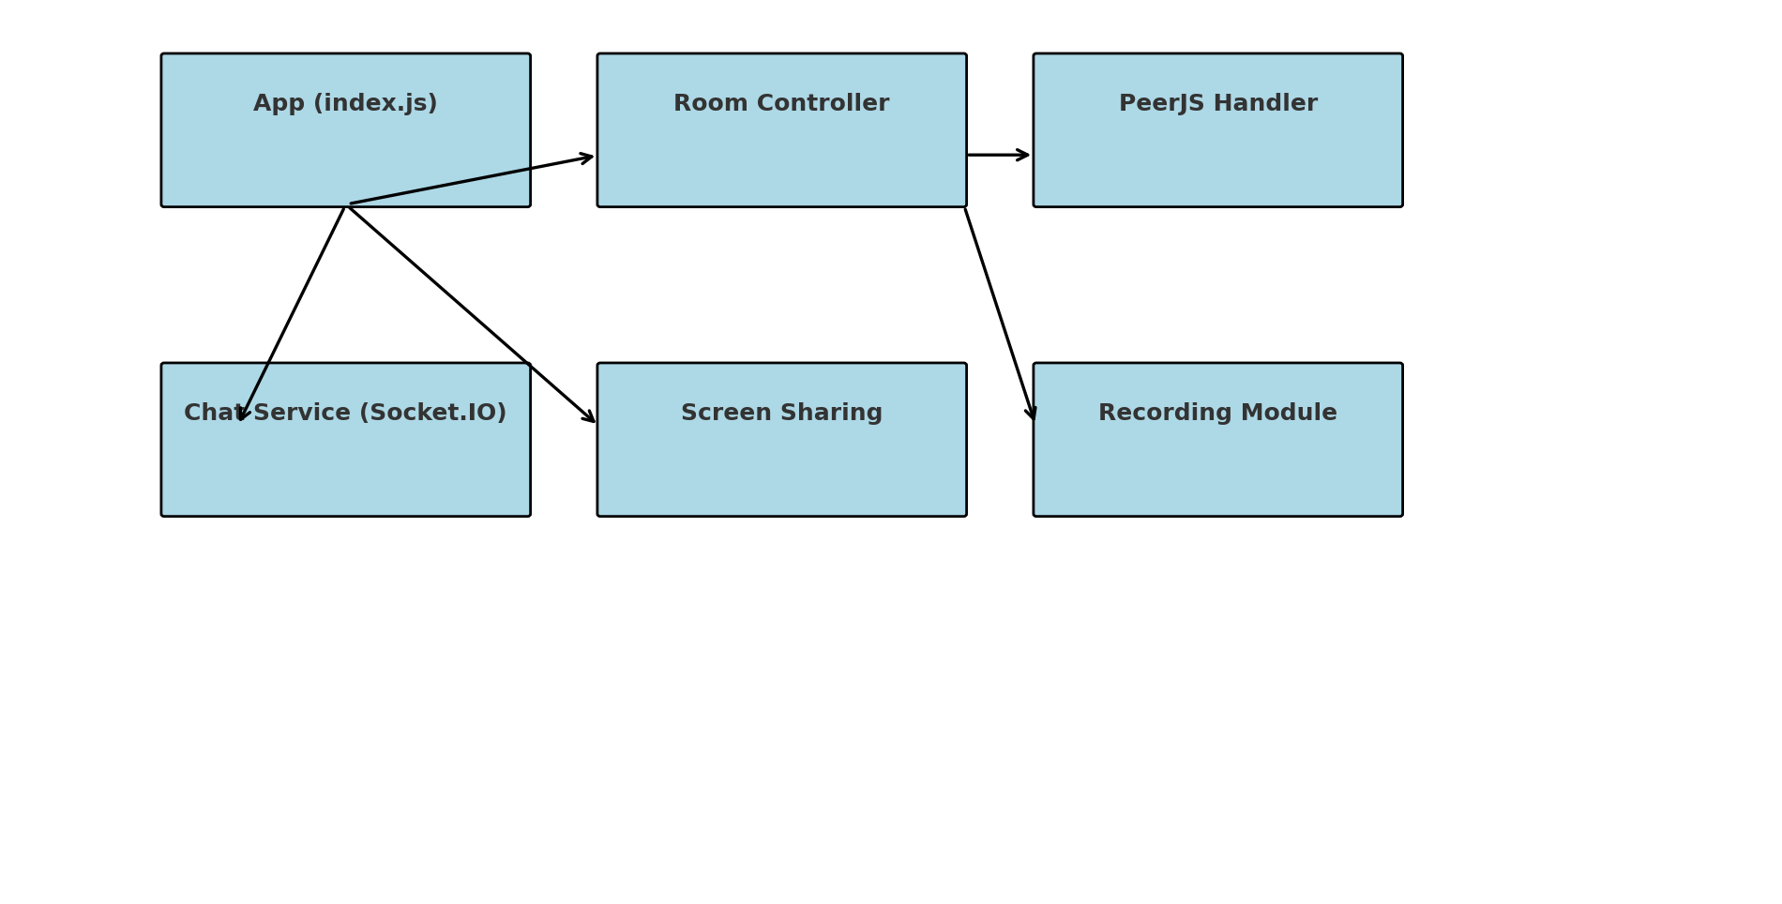

### 2.3 Activity Diagram

This activity diagram outlines the general flow of a user joining a room and starting a WebRTC-based video call.

